49 Flinders Street
Wakool NSW 2710
Phone: 03 5887 1126
Fax: 03 5887 1291
Wakool Burraboi Public School
Newsletter
Term 4 Week 3 2016

Principal’s Report
O
It was pleasing to see all students presented beautifully in school uniform for our school photos which were held last Monday. The photographer will now process the photo orders and have them returned to us later in the term.

As you would be aware over the past week both the Wakool-Deniliquin Road and the Brassi Road has been closed due to flooding. This has obviously impacted Tamara and Mrs PC’s route to travel to and from school. The detour is via the Barham-Deniliquin Road and then onto the Barham-Moulamein Road and finally on the Wakool Road. This will result in longer travel times for both of them whilst flooding is impacting the direct routes. At this stage the school is still accessible. We are very appreciative of their commitment to our school during this time. Therefore this is not having an impact on teaching being provided or on school routines.

Last Friday Mrs PC accompanied Cooper, Jye, Taylah and Isa on their excursion to Bendigo, along with Moulamein PS students. We look forward to hearing about their trip this week. Thank you to all parents for your transport to the departure and pick up point and to Mrs PC for travelling to Barham to accompany the students on the excursion. A big thank you also to Mrs Mertz at Moulamein for her organisation of this excursion, this is very much appreciated by everyone.

We also have two excursions taking place this week. Yesterday morning Jake, Ella and Katie along with Mrs Treble set off for an enjoyable week in Sydney. I look forward to hearing about this exciting trip when they return. Bailey, Mitchell and Declan, along with Moulamein PS are heading to Ballarat on Wednesday for a two-night stay. I am sure they will enjoy trip also.

A reminder to all students and parents if you have any questions or concerns regarding the excursions, please contact the school.

Next week Mrs PC will be away due to family commitments. Normal school routines and learning programs will be in place.

Don’t forget tomorrow night is our P&C Meeting starting at 6:30pm. All welcome, I hope to see you there.

Have a great week! Lisa Chambers Principal

Upcoming Events

This week:

Monday 17th
> Canteen
> Mobile Library
> Yr 5 Excursion
Tuesday 18th
> Yr 5 Excursion
>
Wednesday 19th
> Yr 5 Excursion
> Yr 3/4 Excursion
Thursday 20th
> Yr 5 Excursion
> Yr 3/4 Excursion
Friday 21st
> Yr 5 Excursion
> Yr 3/4 Excursion
> PLAN Training Day 2 – Mrs Chambers and Mrs Pc
> Mrs Young & Makayla Lester
> Homework due
Next Week:
Monday 31st
> Canteen

Tuesday 1st

>
Wednesday 2nd
> No Mrs PC
Thursday 3rd
> No Mrs PC
Friday 4th
> Homework due
> No Mrs PC

Music
This term as part of our Creative Arts program we are focusing on music and dance. Students in Year 3/4/5/6 are learning to play the ukulele. Students in K/1/2 are learning a dance. We are working on putting this together for an end of year performance item.

Science
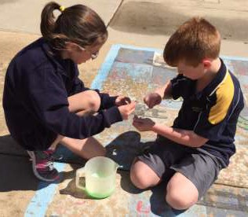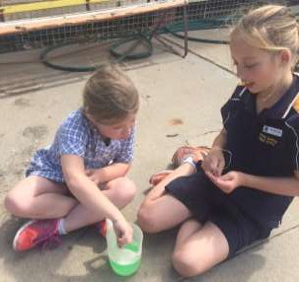Last week our science lesson focused on investigating what a bubble is. Students worked in pairs to design and make a bubble wand to make bubbles. Students used a variety of different bubble mixtures produce bubbles. As part of the experiment students also learnt about the structure of a bubble.

Home readers need to be returned to school every day

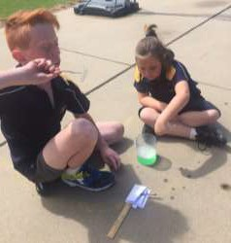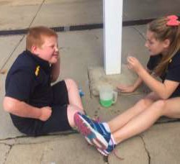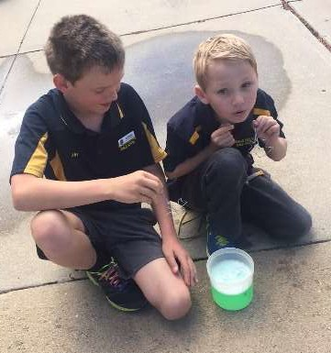Kitchen and Garden Program
As part of our Kitchen and Garden program we have used garden mesh to allow our peas to climb. We have also harvested the cabbages, the remaining silver beet and some radishes. Some corn seeds and bean seeds have also been planted in the past week.

Mrs PC cooked a savoury mince dish last Wednesday with everyone. This used some cabbage from our garden. On Thursday at lunch time students were given the opportunity to taste this dish.

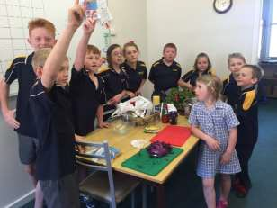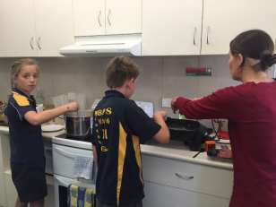

Lunches in the fridge
School library books need to be returned every Monday

If your child would like to place their lunch into the fridge during the warmer weather, please make sure it is clearly labelled. Students will need to place it in the fridge in the morning before the morning session.

Art Project
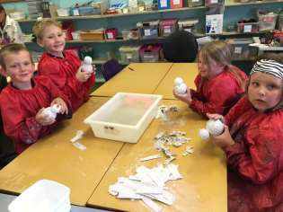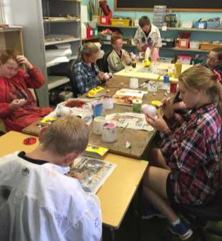Following on with our art plastering project, students in K/1/2 have plaster wrapped a clown body. Students in Year 3/4/5/6 have started to decorate their clowns.

Working with Children’s Check for Volunteers
If you haven’t already contacted the school about your Working with Children’s Check please do so.
It is a requirement that anyone working in a child related activity must now be subject to a “Working with Children’s Check” (WWCC). This includes employees and volunteers at any workplace or organisation involving children, including schools.
The Working with Children’s Check is free for volunteers and can be organised online and through Roads and Maritime Services. For more information please visit: http://www.kidssguardian.nsw.gov.au/working- with-children/working-with-children-check
If you require assistance with this online component please contact the school and we will assist you.
The school must ensure the requirements of this policy are being met. This will ensure we are compliant with current policies.
We will be creating a register of volunteers with the WWCC. Please assist us by contacting the school with your WWCC number (if you already hold a WWCC either as an employee or volunteer) or contact the school to advise us that you will be obtaining one in the near future. When you receive your WWCC you will also need to inform the school.
Please contact the school if you require further information or assistance with this.
HOMEWORK:
If students require
please bring it to school to
ask the teacher on Tuesdays, Wednesdays or Thursdays.

Book Club orders are now due
assistance | with | their
homework | Maths | sheet,

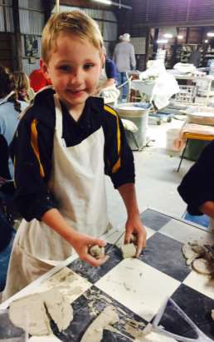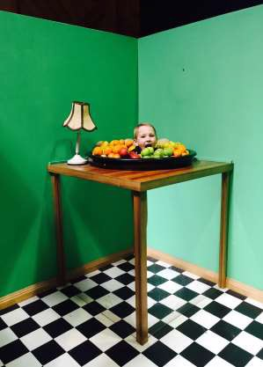K/1/2 Excursion to Bendigo

Last Friday K/1/2 and Mrs PC travelled to Bendigo with students and staff from Moulamein PS for their excursion. I look forward to hearing about their trip this week.
These are the only photos I have from this excursion at this stage.
